Data Access Framework Short Proposal

# Proposed Work Item: *Data Access Framework* (DAF)

Proposal Editor: ONC S&I Framework DAF Support Team (John.Feikema@hhs.gov)

Work item Editor: ONC S&I Framework DAF Support Team (John.Feikema@hhs.gov)

Date: September 29th 2013 **Version: 1.0**

Domain: IT Infrastructure Technical Framework, Patient Care Coordination, Quality, Research and Public Health.

# The Problem

The nation is reaching a critical mass of Health IT systems (EHRs, Data Warehouses etc.) that comply with data and vocabulary standards. The wide deployment of Health IT systems has created unique opportunities for Providers, Provider Support Teams, Healthcare Professionals and Organizations etc. to access and use the patient data that is already collected during clinical workflows. This information may not be readily accessible through the applications to which the relevant party has access. Allowing access to this data can enable a Provider to further analyze the collected data to understand a patient’s overall health, the health of a Provider’s collective patient population, and use the data to power innovative analytics applications and tools to take better care of patients and populations.

From a technology and standards standpoint, data access use cases vary widely and will require Data Access Framework to:

* Support the use of multiple transport protocols such as SOAP, Direct, HTTP with Restful APIs
* Support multiple types of data access mechanisms (for e.g. access data using Document Metadata, access data using data within a document, access data using decision support or quality measure type queries)
* Support data access within a community across systems and across communities
* Support data retrieval of patient level data or population level data including highly protected health data such as behavioral or substance abuse data

A single profile typically does not address all of the above dimensions; however creating a framework of modular, substitutable, interoperable profiles will enable data access for a wide variety of use cases and reduce integration costs by encouraging standards based integration both within and across communities.

# Key Use Case

The following are some key use cases that DAF is expected to support:

* Allow healthcare professional to access patient data using ad-hoc queries for accessing clinical summaries for the past 5 years to check for their HbA1C levels within and across communities.
* Allow healthcare professionals to retrieve patient level data for patients whose last lab test had a HbA1C was greater than 7% both within and across communities.
* Allow healthcare professionals to access population level data corresponding to all diabetics so that the population can be broken up into cohorts for appointment scheduling.
* Allow healthcare professionals to extract all healthcare records for a patient who is moving from one state to another state and requires the records.

# Standards & Systems

The following is an example of a DAF modular standards stack and list of candidate standards.

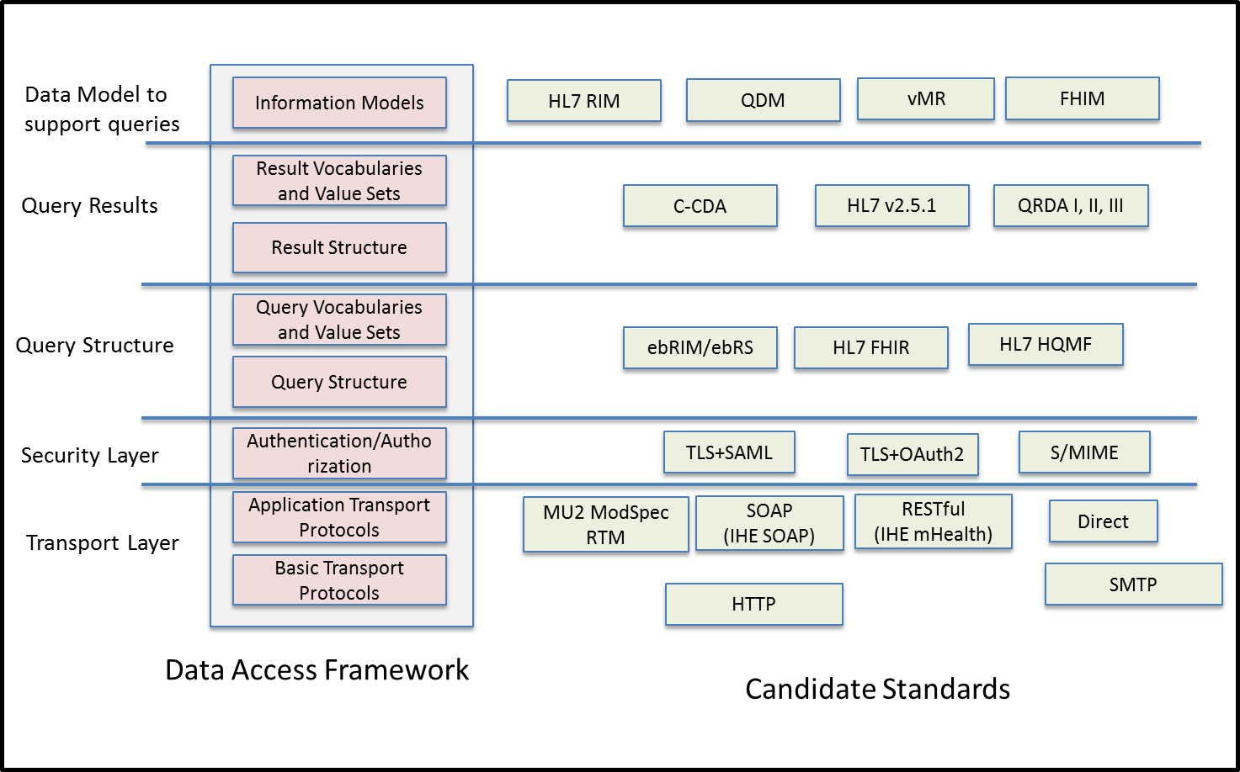

# Discussion

IHE would be a good venue to solve this problem because it involves developing a profile across several existing standards and profiles. The experience of the IHE community to develop integration profiles will be heavily leveraged in building out the modular DAF standards stack and many of the existing IHE profiles such as (XCA, mHealth, MPQ etc.) can be leveraged for the various data access use cases. IHE also has the required expertise working with standards from SDO’s such as W3C, OASIS, and HL7, creating the necessary integration profiles for healthcare.